



**Space Art**

**Create your own space picture. Use this sheet to plan your work.**

What will be the subject of your picture? A satellite, a star, a rocket, a planet, a constellation?

What view will you use e.g. looking up into space or down, back at Earth?



What colours, shapes, lines, tones will you use?

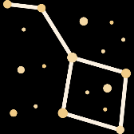

List of equipment and resources. Will you use pencil, crayon, paint or materials or could you create your piece of art using a computer program?

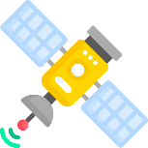

How do you want the person viewing your art to feel? Amazed, terrified, content?