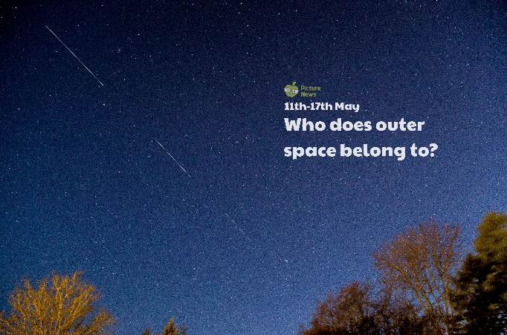

Cut out the stars and complete the challenges on the star maths sheet exploring numbers 0 – 20. If you need more of a challenge, create your own star number cards!

Do you think SpaceX should be able to send satellites into orbit to provide internet for the world? Discuss your thoughts with someone at home and list the reasons for and against your own opinion.

Create your own song or rap about something in space such as a star, a planet, a satellite or perform one you already know such as ‘Twinkle, Twinkle, Little Star’. Make sure you include actions!

Read and research the history of the internet. Can you find out when it first began? When was the World Wide Web invented?

Observe the night sky. Can you see the moon? Can you see any constellations? What else can you see? Record your findings.

Space Art! Create your own space picture. What will be the subject of your picture? A satellite, a star, a rocket, a planet, a constellation? What view will you use e.g. looking up into space or down, back at Earth? What colours, shapes, lines and tones will you use? Will you use pencil, crayon, paint or materials or could you create your piece of art using a computer program?

Jot down as many words as you can to describe a star. Use these words to write a sentence describing a star or to create a poem. Don’t forget to include a picture.

**Learning from Home**

Use the ideas below, alongside this week’s resource, to support your home learning.