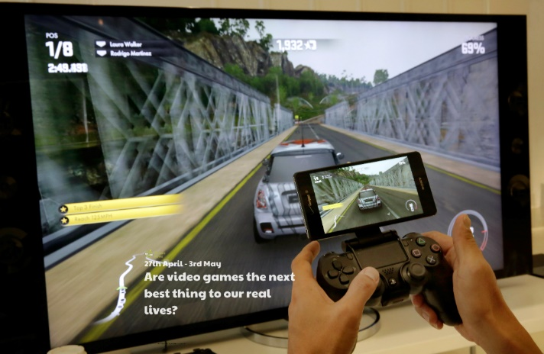

Create your own sports game or adapt an existing sports game so that you can play it with the space you have during lockdown!

Write a set of instructions for a game. This could be for a game you have created yourself or for one of your favourite games.

Design a poster to advertise one of your favourite games. This could be a video game or another type of game.

Think about the games you play on the playground. Can you find out what games adults in your home used to play at school? What about your grandparents? What is different/the same about the games you play and the ones played in the past?

Play a video game to help you practise something or learn something new e.g. mental maths or a new language.

Design and make your very own board game! Think about its name, the object of the game, number of players, rules, the design of your game – shape, size, colour.

Write a video game review. Include the name of the game, what you have to do, what age it is suitable for, what you like/dislike about it. You could even get technical and describe and review the graphics, sound effects, characters, special features, controls.

**Learning from Home**

Use the ideas below, alongside this week’s resource, to support your home learning.