

**My journey**

Imagine you are going on a journey. You can travel anywhere you want!

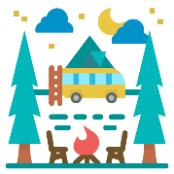

**Picture**

Where will you go? ________________________________________

________________________________________________________

How will you travel there? ___________________________________

________________________________________________________

Who will you go with? ______________________________________

How long will it take? _______________________________________

What will the journey be like? ________________________________

________________________________________________________

________________________________________________________