Building Learning Power at Aqueduct Primary School
At Aqueduct Primary School we expect each child to work hard and achieve the highest possible standards, whilst having fun! We aim for every child to leave Aqueduct Primary School, having achieved the very best that they can and feeling proud of their achievements.
In order to do this, we explicitly teach the following life skills, to ensure that our learners are resilient, resourceful, reflective and reciprocal in their next stage of learning and beyond.

Be a Tough Tortoise – Be Resilient
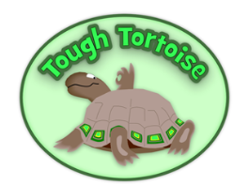

Resilience is being ready, willing and able to lock onto learning; knowing how to work through difficulties when the pressure mounts or the going gets tough.
Resilience is made up of:
- Absorption - being able to lose yourself in learning; becoming absorbed in what you are doing.
- Managing distractions – recognising and reducing distractions; knowing when to walk away and refresh yourself; creating your own best environment for learning.
- Noticing – seeing subtle differences, patterns and details in experience.
- Perseverance – keeping going in the face of difficulties; channelling the energy of frustration productively; knowing what a slow and uncertain process learning often is.

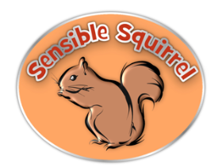
Be a Sensible Squirrel – Be Resourceful

Resourcefulness is being ready, willing and able to learn in different ways, making full use of the resources available.
Resourcefulness is made up of:
- Questioning – asking questions of yourself and others; being curious; wanting to find things out; wanting to know about things in more depth.
- Making links – seeing connections between totally different events and experiences; building patterns and weaving a web of understanding.
- Imagining – using your imagination and intuition; exploring new experiences and possibilities; wondering ‘What if…?’
- Reasoning – working things out methodically and rigorously; constructing good arguments and spotting flaws in others’ points of view.
- Capitalising – drawing on the full range of resources from the wider world, other people, books, the Internet, past experience and future opportunities.

Be a Wise Owl – Be Reflective
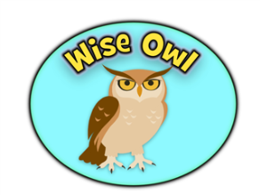

Reflectiveness is being ready, willing and able to become more strategic about learning. You take a longer-term view by planning, taking stock, and drawing out your experiences.
Reflectiveness is made up of:
- Planning – thinking about where you are going, the action you are going to take, the time and resources you will need and the obstacles you may encounter.
- Revising – being flexible, changing your plans in the light of different circumstances; monitoring and reviewing how things are going and seeing new opportunities.
- Distilling – looking at what is being learned, pulling out the essential features, carrying them forward to aid further learning; being your own learning coach.
- Meta-learning – knowing yourself as a learner, how you learn best; how to talk about the learning process

Be a Team Ant – Be Reciprocal
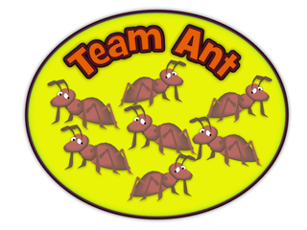

Reciprocity in learning is being ready, willing and able to learn alone or with other people; using a sense of independent judgement together with skills in communication and empathy.
Reciprocity is made up of:
- Interdependence – knowing when it’s appropriate to learn on your own or with others and being able to stand your ground in debate.
- Collaboration – knowing how to manage in the give and take of a collaborative activity; respecting and recognising other view points; adding to and drawing from the strength of teams.
- Empathy and listening – contributing to others’ experiences by listening to them to understand what they are really saying, and putting yourself in their shoes.
- Imitation – constructively adopting methods, habits or values from other people who you watch.

